Lionbridge Connector for Sitefinity
Built by Progress Software, the fully integrated Sitefinity Connector for Lionbridge translation capability allows users to easily select content for translation, choose one or many target languages, add-job specific information and send content out to be translated.
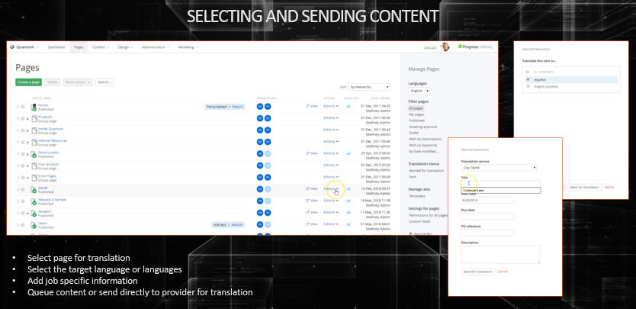
Content is packaged into a translation ready file format and is sent over to Lionbridge. Lionbridge automatically receives the file, creates a translation job, and leverages any previously translated content from your organizations Translation Memory. Content can then be translated and sent back through the Connector, where the target pages are populated with the translated content.

Connector Pricing
The Sitefinity Connector for Lionbridge is sold as part of the Sitefinity offerings from Progress Software.
Lionbridge provides the access to allow content to leave the Connector and reach their translation service. Lionbridge also provides support to help customers get set up, as well on-going customer technical support for customer who are having connectivity issues.
Certification Testing and Implementation Support | $5000 USD
On-going Technical Support | $1000/month USD

